Right To Data Portability Procedure.

Contents

Purpose 2

Scope 2

Review 2

Right To Access Procedure 3

The Procedure. 4

# Purpose

The purpose of the Right to data portability procedure is that Metropolis will be able to transfer the personal data directly to another data controller specified by the individual. This means if an individual wants their data moved from Metropolis to another service provider, Metropolis should facilitate this transfer directly if technically feasible.

# Scope

The procedure specified in this document applies to all information resources and assets that are owned by the company. And it’s applied to all staff, contractors, third parties, and to all other individuals or organizations who use, or support the use of the organization information processing environment. This procedure applies entirely in the organization.

# Review

The document shall be reviewed at least for each two months in case of major changes.

# Right To Data Portability Procedure

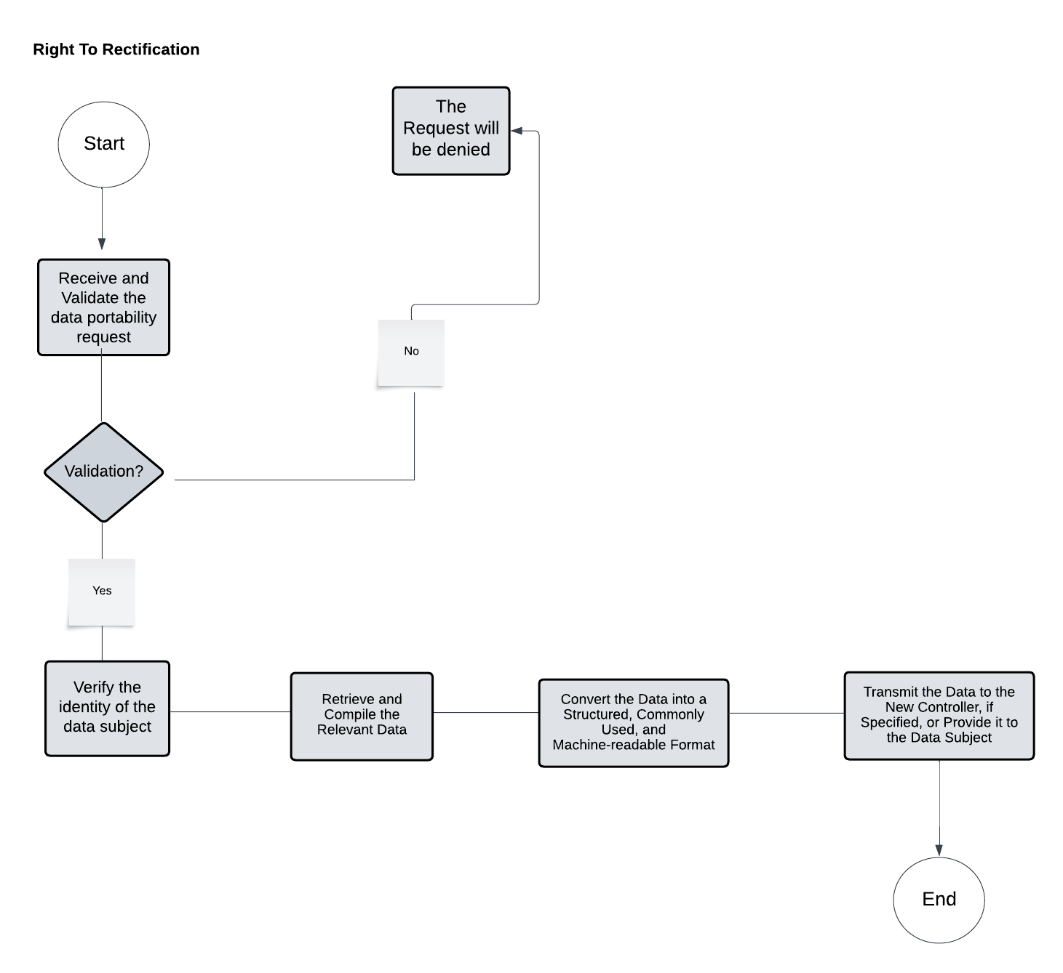

|  |  |  |
| --- | --- | --- |
| **The Activity ID** | **The Activity** | **Description on The Activity** |
| 1 | Receive and Validate the Data Portability Request | Confirm that the request includes information about where and how the data should be sent. |
| 2 | Verify the Identity of the Data Subject | Implement identity verification mechanisms (for example, demanding ID and comparing personal information).  Ascertain that the person making the request is the data subject or a legally authorized representative, which is critical for such a substantial step as data deletion.  ensuring the data isn't sent to an unauthorized person. |
| 3 | Retrieve and Compile the Relevant Data | Collect data that is subject to portability rights, typically data provided by the subject or generated through the subject's activities. |
| 4 | Convert the Data into a Structured, Commonly Used, and Machine-readable Format | Prepare the data in formats like CSV, XML, or JSON, which are widely used and easily integrated into other systems. |
| 5 | Transmit the Data to the New Controller, if Specified, or Provide it to the Data Subject | Securely transfer the data to the specified recipient or make it available for the subject to download. |

## The Procedure.